Abinaya B T (22ISR001)

**TASK 1**

**Create a simple FreeStyle Job to Install Nginux on you server (tools:Jenkins,Ubuntu vm)**

**Step 1: Create a Jenkins Job to Install Nginx:**

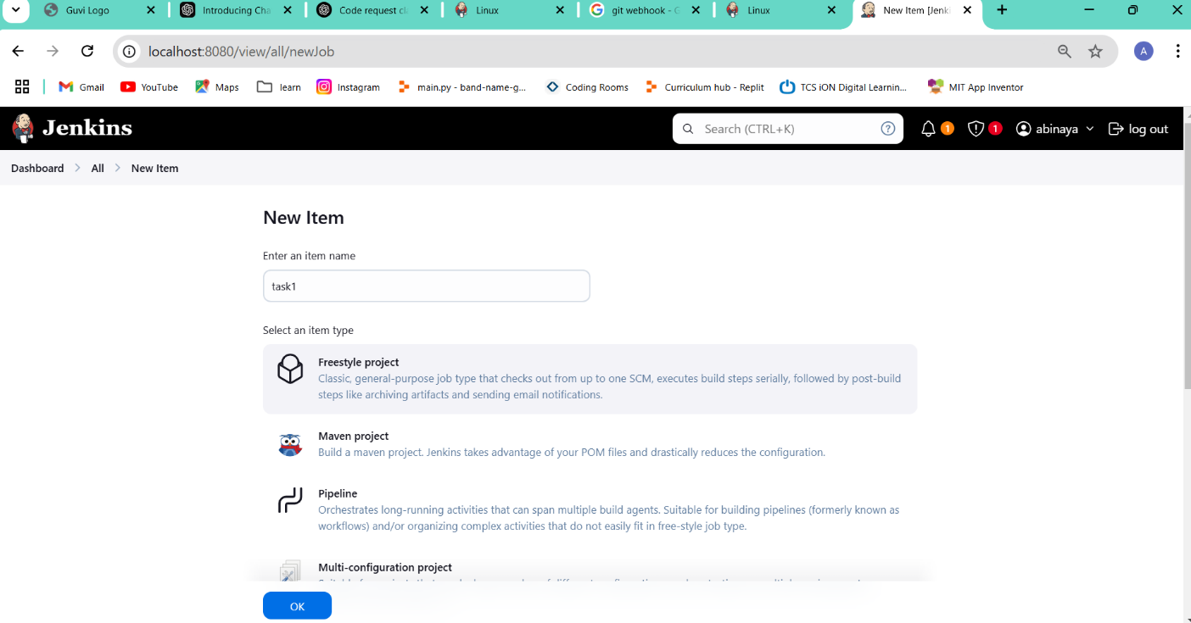

* **Open Jenkins Dashboard**.
* Click on **"New Item"** → **"Freestyle Project"** → Name it **task1**.
* Click **OK**.

**Step 2: Creating a directory and creating index.html file in it:**

sudo mkdir -p /var/lib/jenkins/workspace/html_files

sudo chmod -R 777 /var/lib/jenkins/workspace/html_files

sudo nano /var/lib/jenkins/workspace/html_files/index.html

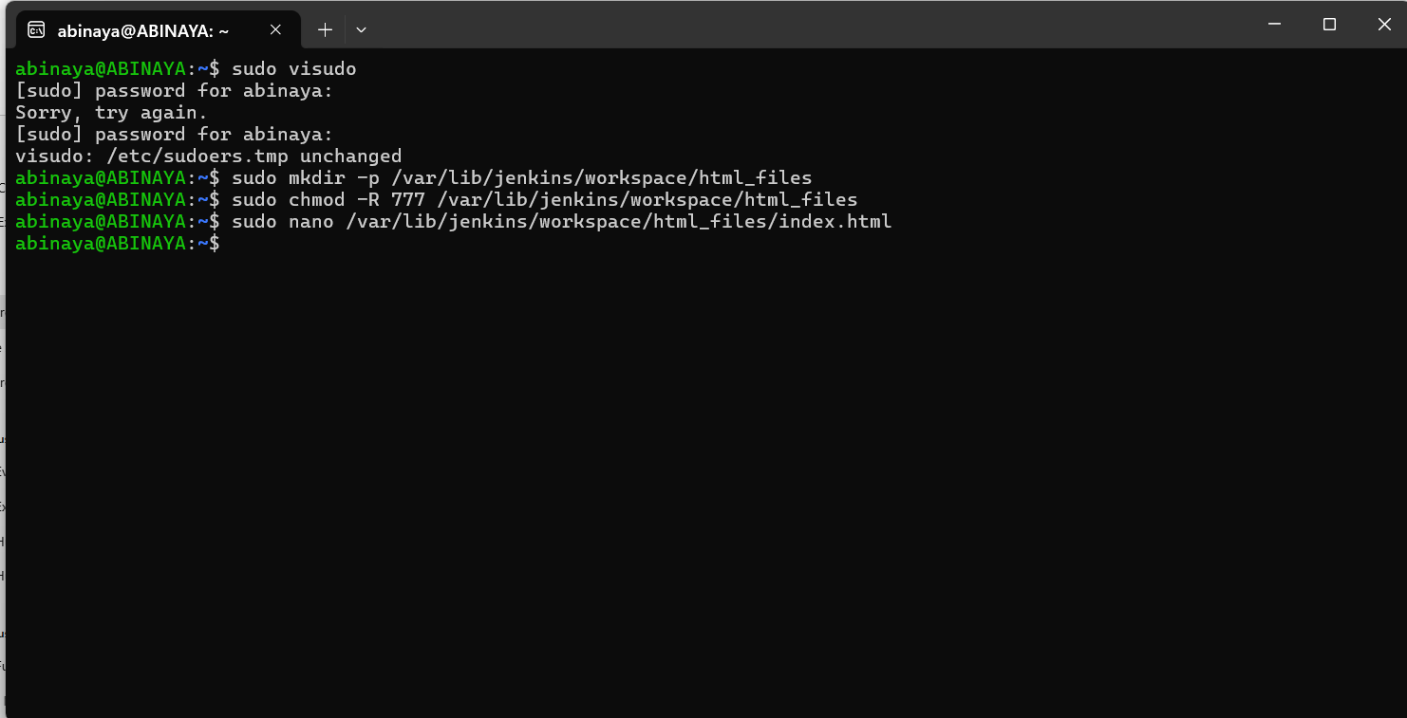

**index.hmtl:**

<!DOCTYPE html>

<html lang="en">

<head>

<meta charset="UTF-8">

<meta name="viewport" content="width=device-width, initial-scale=1">

<title>Guvi Home</title>

<style>

/* Basic CSS styling for layout */

body {

margin: 0;

font-family: Arial, sans-serif;

background-color: #f2f2f2;

}

header {

background-color: #ffffff;

padding: 10px 20px;

display: flex;

align-items: center;

box-shadow: 0 2px 4px rgba(0,0,0,0.1);

}

header img {

height: 40px;

}

nav {

margin-left: auto;

}

nav a {

margin: 0 15px;

text-decoration: none;

color: #333;

font-weight: bold;

}

.hero {

background: url('https://www.guvi.in/images/hero-bg.jpg') no-repeat center center;

background-size: cover;

color: #fff;

padding: 100px 20px;

text-align: center;

}

.hero h1 {

font-size: 48px;

margin-bottom: 20px;

}

.hero p {

font-size: 18px;

margin-bottom: 30px;

}

.hero a {

display: inline-block;

background-color: #007BFF;

color: #fff;

padding: 12px 25px;

text-decoration: none;

border-radius: 4px;

font-size: 16px;

}

.container {

padding: 40px 20px;

background-color: #fff;

margin: 20px auto;

max-width: 1200px;

box-shadow: 0 2px 4px rgba(0,0,0,0.1);

}

footer {

background-color: #333;

color: #fff;

text-align: center;

padding: 15px;

}

</style>

</head>

<body>

<header>

<!-- Guvi Logo -->

<a href="index.html">

<img src="https://www.guvi.in/images/guvi-logo.svg" alt="Guvi Logo">

</a>

<!-- Navigation Menu -->

<nav>

<a href="#">Courses</a>

<a href="#">About</a>

<a href="#">Contact</a>

<a href="#">Login</a>

</nav>

</header>

<!-- Hero Section -->

<section class="hero">

<h1>Welcome to Guvi</h1>

<p>Empowering you with coding skills for the future.</p>

<a href="#">Get Started</a>

</section>

<!-- Main Content Section -->

<div class="container">

<h2>Our Courses</h2>

<p>Explore our diverse range of courses designed to help you master the latest technologies in coding, data science, and more.</p>

<!-- Additional content can be added here -->

</div>

<!-- Footer -->

<footer>

<p>&copy; 2025 Guvi. All rights reserved.</p>

</footer>

</body>

</html>

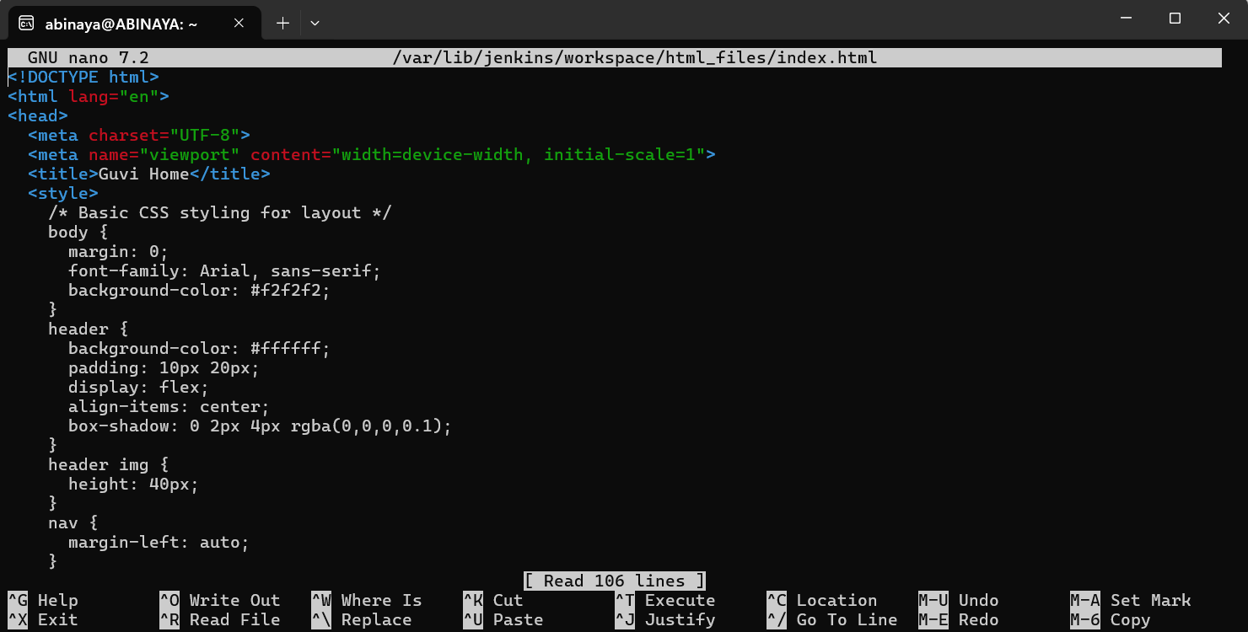

**Step 3: Open the execute shell and enter the following command:**

# Create a directory for logs or temporary files

mkdir file5

# Update system packages

sudo apt update && sudo apt upgrade -y

# Install Nginx if not installed

sudo apt install nginx -y

# Start and enable Nginx service

sudo systemctl start nginx

sudo systemctl enable nginx

# Check if Nginx is running

systemctl status nginx

# Update package list again

sudo apt update

# Copy the HTML file from Jenkins workspace to Nginx document root

sudo cp /var/lib/jenkins/workspace/html_files/index.html /var/www/html/

# Restart Nginx to apply changes

sudo systemctl restart nginx

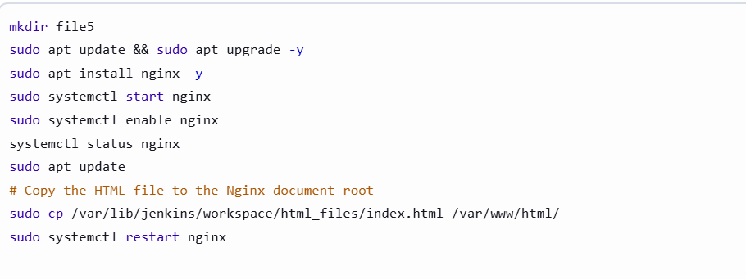

**Step 4: Run the Jenkins Job**

1. Click on "Build Now" to start the job.

**Step 5: Verify the Build and Check Console Output**

1. After the build finishes, click on "Console Output" to verify if there are any errors.
2. Ensure that all the commands executed successfully**.**

**Verifying nginx is installed through jankins:**

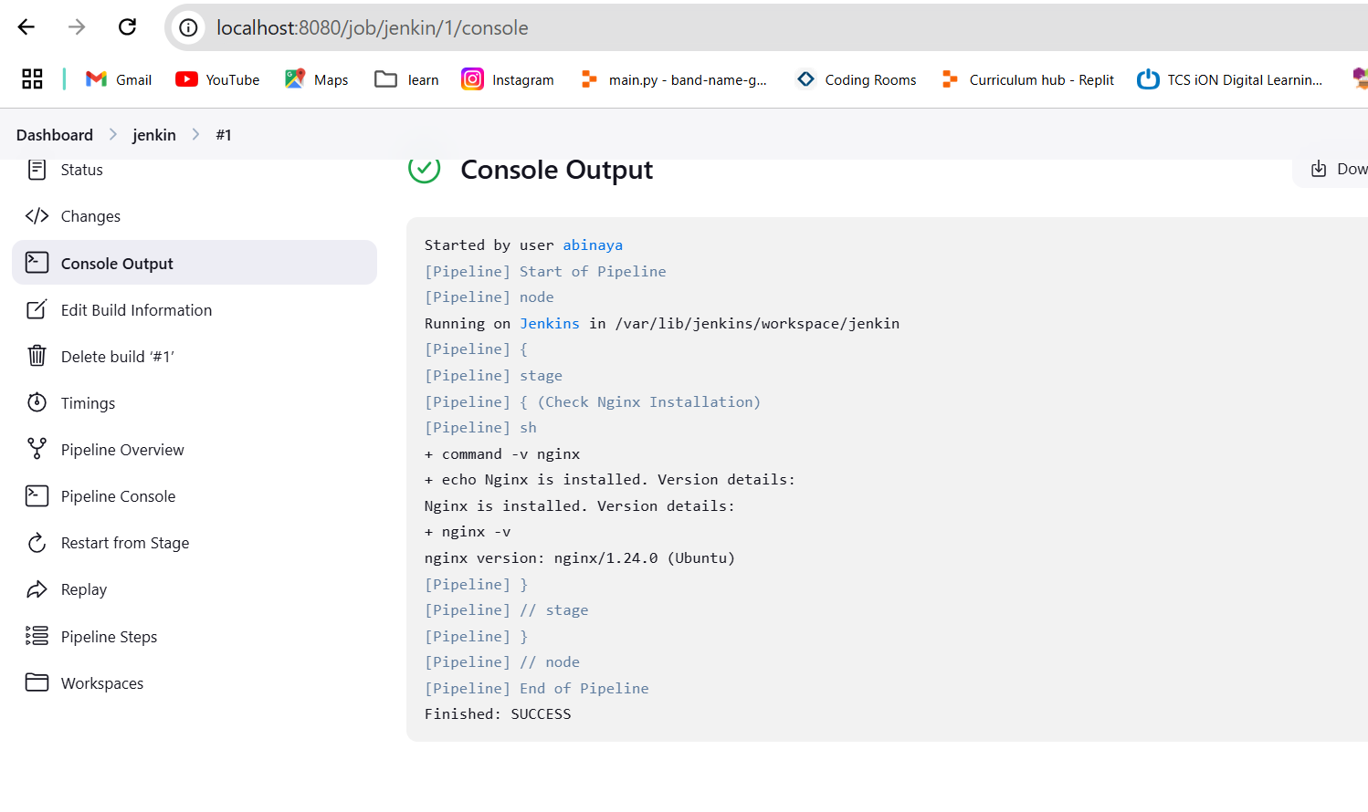

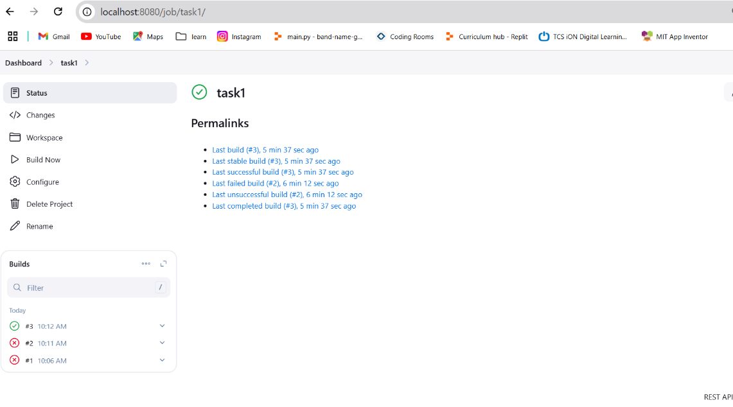

**Console output:**

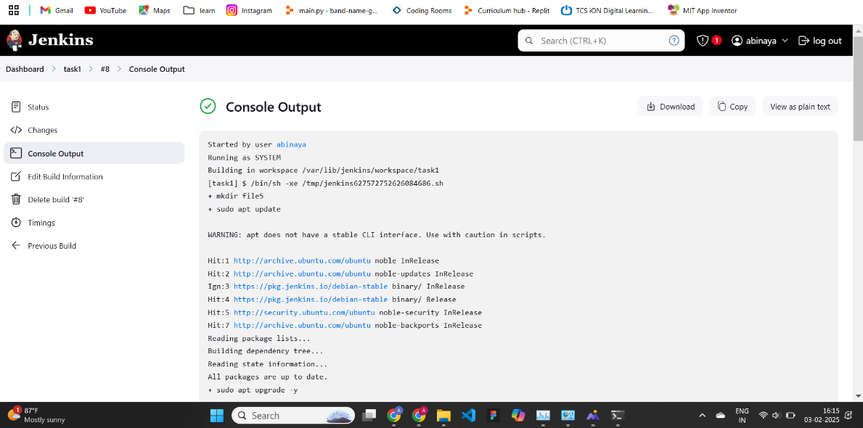

**Step 6: Verify the Output**

1. Open a browser and go to **http://localhost:80**.
2. You should see the GUVI webpage hosted via Jenkins and Nginx with the content specified in the index.html file.

